
How to build you own rye/bread flour sourdough starter - Udi Galili
On the net there are many recipes, sourdoughs of different types (white, spelt, rye, etc.) and all kinds of preparation methods (starting with raisin water, honey and different feeding measurements every day).

I chose to go in a different direction.
Feeding will be very simple. consistent
But you are required to be vigilant and have a basic understanding that will serve you in the future as well.

what does it mean?
Making sourdough bread requires attention and emotion for the dough. A recipe does not help if there is no basic understanding of the process itself and the developments of the dough according to various factors.
I want to say that it is important to understand from the beginning that the next step in the leaven/dough depends on the rate of progress of the leaven/dough. You will understand later.

The required equipment:
* A box - preferably narrow, round and tall such that you can easily mix the sourdough in it. About the size of a can.

* Whole rye flour. Start feeding the sourdough from a new bag to maintain consistency in the type of flour.

* Water - preferably minerals.

Preparation:
Before we begin, we will weigh the box without the lid and write its weight on the box. This will serve us later.
Also, during the entire process, the sourdough will remain closed outside the refrigerator and in a shaded area.
In addition to all this, smell the sourdough daily. Make sure you haven't raised mold. The smell will be sour and pleasant.

On the first day:
I recommend starting at 7pm. Optional.
Place the box on the scale and reset the scale. Add 100 g of water and 100 g of rye flour on top. Mix and leave on the counter for 24 hours.
At the end of them, you probably won't see a change in the sourdough. It will be good if you see small holes at the top.

On the second day until the seventh day
Refresh the sourdough as follows:
Weigh the box with the sourdough and leave in it the weight of the box plus 40 grams of sourdough.
The rest is thrown away.
Add 100 g of water to the sourdough, mix, then add 100 g of rye flour.
We will mark with an eraser/marker the level of the surface of the sourdough to identify its development.

For the purpose of the example: let's say the weight of the empty box was 100 grams. After the first feeding the weight will show 300 gr (100 gr the weight of the box + 100 gr water + 100 gr flour).
In the next refresh, we will leave 40 grams of sourdough in the box, which means the weight should show 140 grams. (This is why we weighed the box and wrote it down).

When will we refresh?
While the sourdough seems to have swelled and reached its peak. To identify the peak of the sourdough you will have to occasionally look at it and follow.
It won't be critical if you arrive after peak and it won't be critical if you refresh before peak.
But it is recommended to refresh at its peak.
About how much time?
12 hours to 18 hours. It depends on the ambient temperature.
In winter it will take more time for sourdough. Less time in the summer.

Simple - but requires your follow-up.

What happens after the first week?
First of all, if you see that the sourdough is lively and active, you can make bread.

After the week, you can continue in the same way for another two weeks to establish the nature of the sourdough.
And you can put it in the refrigerator, and once every 3 days take out the sourdough leave 40 grams, feed with 100 grams of water and 100 grams of flour. Wait for the sourdough to start fermenting (about 4-5 hours) and put it back in the fridge until the next time.

For baguette I recommend to use a white bread flour sourdough.
So you build a rye sourdough as mention above and on the eighth day gradually feed the sourdough with a bread flour.
For Example the feeding on the eighth day will be like that:
of 80 grams of rye flour and 20 grams of white flour.
The next day 60 rye and 40 white
The next day 40 rye and 60 white
And so on until complete conversion.

First day- just after mixIng
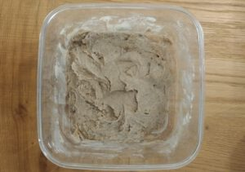
After 24 hours from the firts feeding. There isn’t any activity
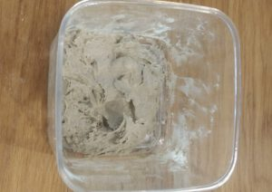
The second day- after 16 hours from the feedind you can see an activity
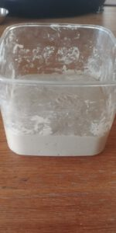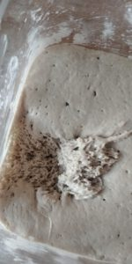
On the third day -there is no big change
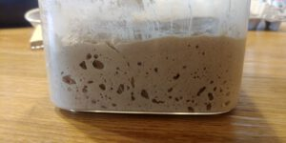

On the fifth day
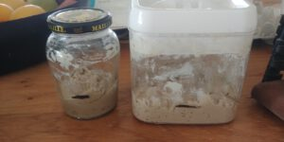

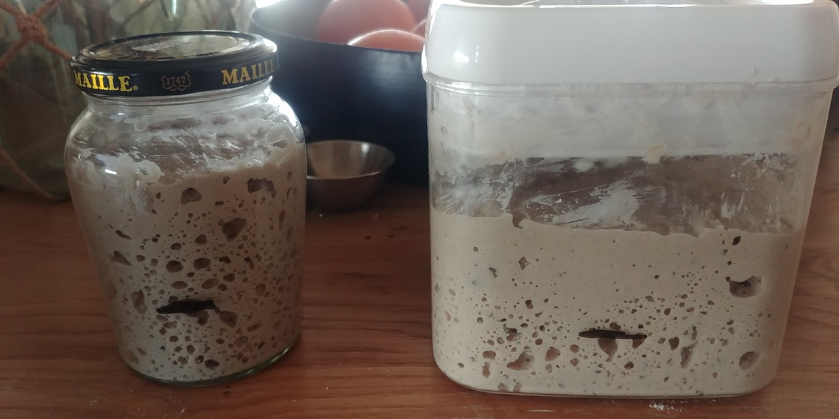

On the sixth day leavening is very active and now you can gradually feed the sourdough with a bread flour.



